**Name:** Nishan Paul

**ID:** 1604085

**Course Title:** Computer Graphics (Sessional)

**Course No:** CSE-458

**Level 4, Term 1**

**Assignment 03**

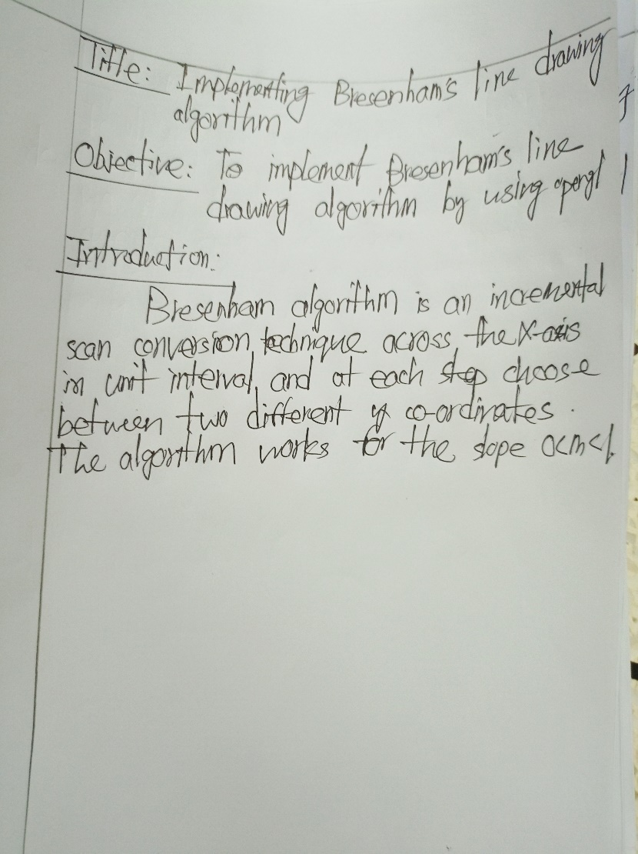

**Code:**

#include<windows.h>

#include<GL/glut.h>

#include<stdlib.h>

#include<stdio.h>

using namespace std;

void algo_1st(int x1, int y1, int x2, int y2) {

glBegin(GL_POINTS);

glVertex2i(x1, y1);

int dx = abs(x2-x1);

int dy = abs(y2-y1);

int incx = x2<x1? -1 : 1;

int incy = y2<y1? -1 : 1;

int x = x1;

int y = y1;

int e = dx>dy? 2*dy-dx : 2*dx-dy;

int ifst = dx>dy? 2*(dy-dx) : 2*(dx-dy);

int isec = dx>dy? 2*dy : 2*dx;

int limit = dx>dy? dx:dy;

for(int i=0; i<limit; i++) {

if (e >= 0) {

if(dx > dy) y += incy;

if(dx <= dy) x += incx;

e += ifst;

}

else

e += isec;

if(dx > dy) x += incx;

if(dx <= dy) y += incy;

glVertex2i(x, y);

}

glEnd();

glFlush();

}

void init(void) {

glClear(GL_COLOR_BUFFER_BIT);

glClearColor(0,0,0,0);

glMatrixMode(GL_PROJECTION);

glLoadIdentity();

gluOrtho2D(0, 640, 0, 480);

}

int main(int argc, char** argv) {

glutInit(&argc, argv);

glutInitDisplayMode(GLUT_SINGLE|GLUT_RGB);

glutInitWindowSize(1000,1000);

glutInitWindowPosition(100,100);

glutCreateWindow("3rd Task");

init();

glutDisplayFunc([]() {

algo_1st(100,100,300,100);

algo_1st(300,100,300,200);

algo_1st(300,200,100,200);

algo_1st(100,200,100,100);

});

glutMainLoop();

return 0;

}

**Output:**



